**Context Diagram** The first DFD in every business process model, whether a manual system or a computerized system, is the context diagram. As the name suggests, the context diagram shows the entire system in context with its environment. All process models have one context diagram. The context diagram shows the overall business process as just one process (i.e., the system itself) and shows the data flows to and from external entities. Data stores usually are not included on the context diagram, unless they are “owned” by systems or processes other than the one being documented.

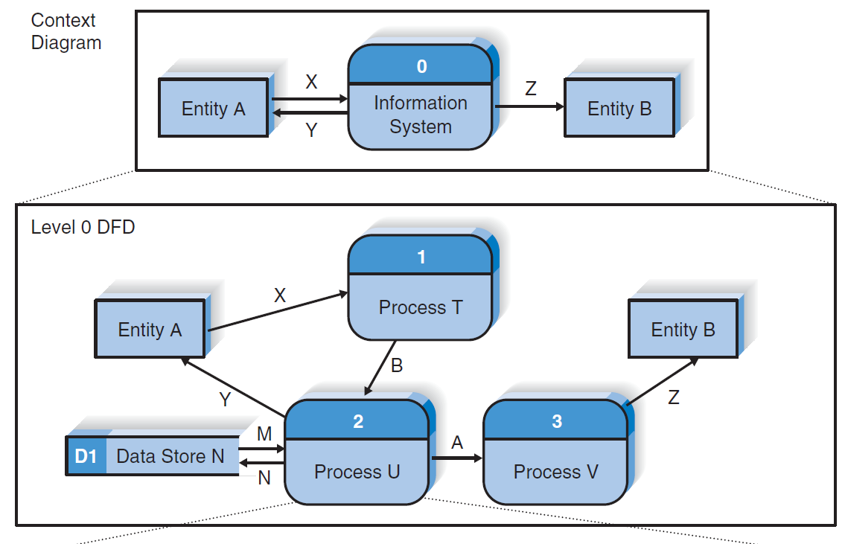**Level 0 Diagram** The next DFD is called the level 0 diagram or level 0 DFD. (See Figure 5-3.) The level 0 diagram shows all the processes at the first level of numbering (i.e., processes numbered 1 through 3), the data stores, external entities, and data flows among them. The purpose of the level 0 DFD is to show all the major high-level processes of the system and how they are interrelated. All process models have one and only one level 0 DFD. Another key principle in creating sets of DFDs is balancing. Balancing means ensuring that all information presented in a DFD at one level is accurately represented in the next-level DFD. This doesn’t mean that the information is identical, but that it is shown appropriately.

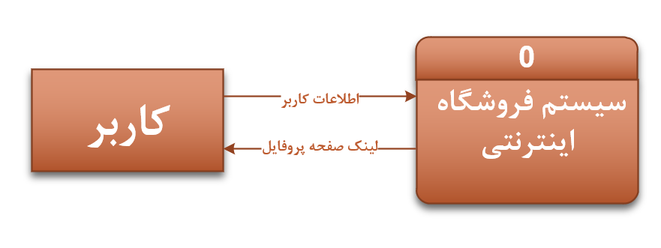

**Use Case Name:** ثبت نام کاربر

**Context Diagram 1**

**Context Diagram 2**

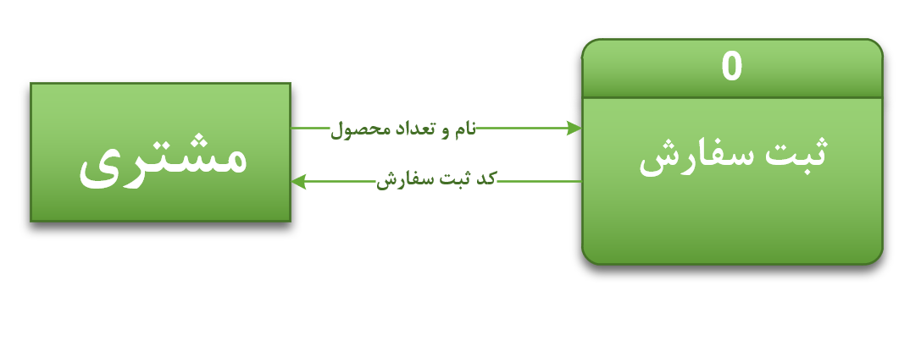

**Use Case Name:** ثبت سفارش

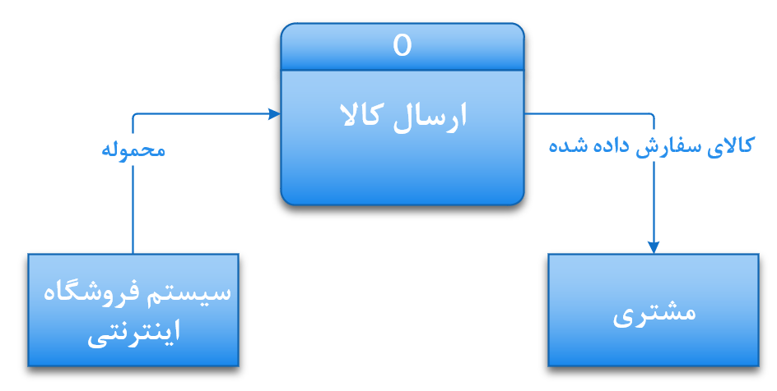

**Use Case Name:** ارسال کالا

**Context Diagram 3**

**کد پیگیری سفارش**

**Data Flow Diagram 1**

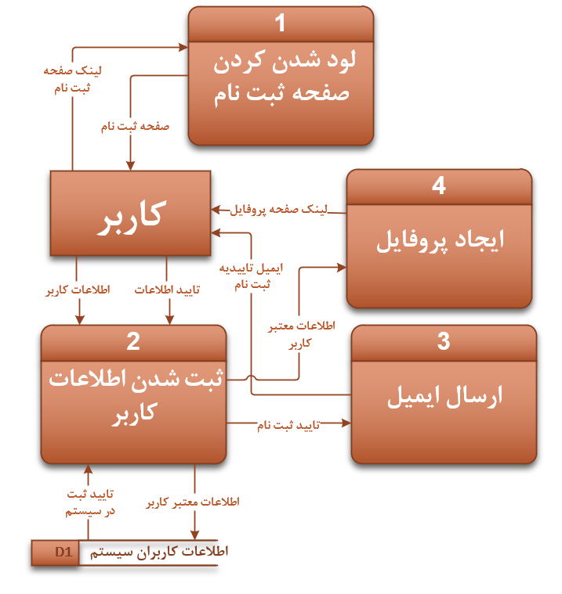

**Data Flow Diagram 2**

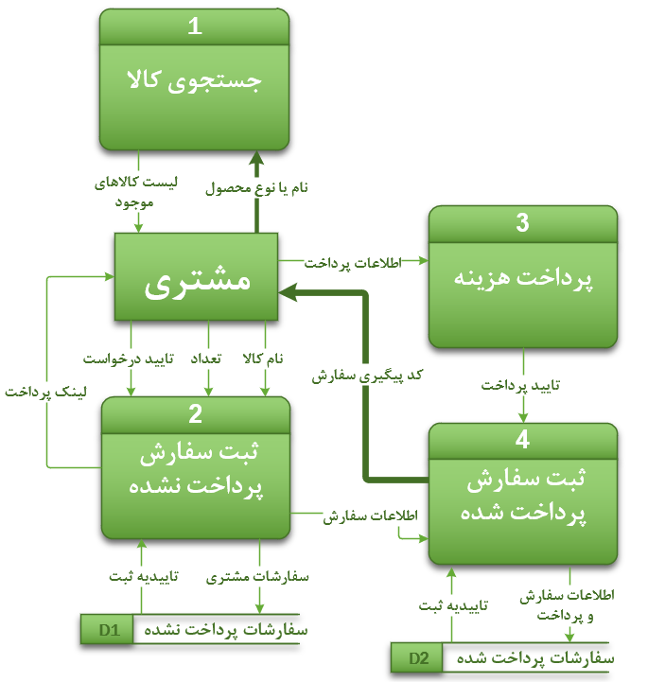

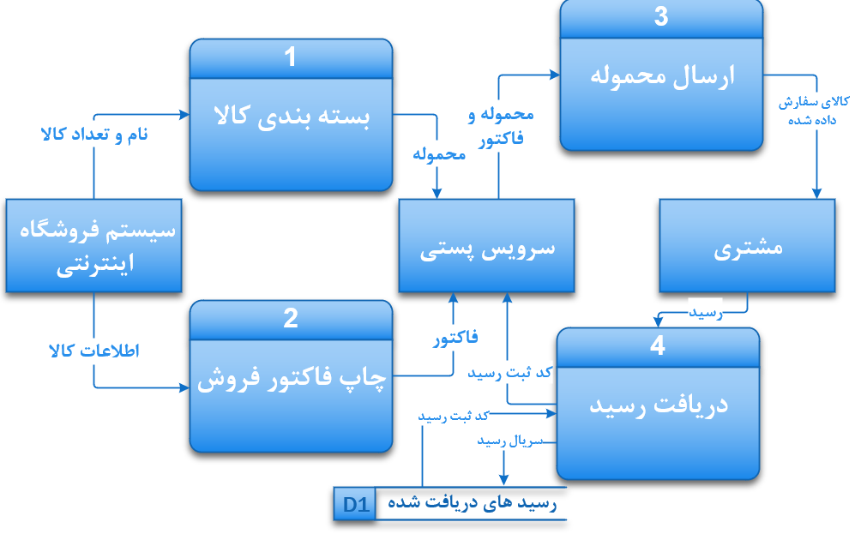

**Data Flow Diagram 3**